Disney World Doesn’t Have to Be Confusing: How to Have a Successful Trip.



It is not unknown that Disney World can be stressful and aggravating at times for guests. Planning a trip to Disney World is expensive and can often come with complexities that are hard to navigate. The parks themselves can be crowded and confusing to those who are new or infrequent visitors. I’m here to help. I will lay out how to not only get your money’s worth at Disney but also have a less stressful and chaotic time. I will also include some friendly tips that I have found helpful in my frequent visits to Disney World.

- Stay on property: while this is the more expensive option upfront, the ease of transportation, location, and assistance you will find at one of the parks’ resort properties outweigh the cost of staying off property.
- Have a game plan going in. Decide ahead of time which park you are going to. If you are planning a trip to Disney longer than a day you can schedule the days you want to visit each park.
- Purchase Genie+: while this is an unfortunate added expense it ensures you can enjoy more rides with shorter wait times.
- Decide the things that are important to you and rank them by priority.
- Rides
- Parades
- Shopping
- Photos
- Food
- Wear comfortable clothes and good walking shoes.
- Bring a refillable water bottle as you need lots of fluids and purchasing drinks in the park is expensive.
- Bring sunscreen, sunglasses, a portable charger, and a fully charged phone to start the day.

- Download the My Disney Experience app as this contains necessary information and reservations throughout the day, and the park maps.
https://disneyworld.disney.go.com/guest-services/my-disney-experience/mobile-apps/

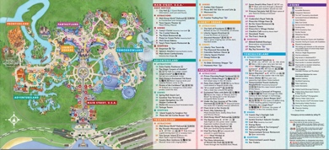
- Make sure to allow downtime. Taking time to rest and grab a bite to eat/drink water is vital to not overexert yourself.

I hope you find these tips helpful on your next trip to Disney World. It can be a stressful time, but if you go in with a plan you can strongly diminish the chaos and confusion. If possible, working with a Disney Travel Agent is another great way to minimize the stress of Disney. Lastly, remember Disney is about having fun, try to take it all in, and slow down to enjoy the magic.

